**M.S.SANJAY**

**15BCE0517**

**Microprocessor and Interfacing**

**Lab Experiment 8**

1. **7-Segment LED Display**

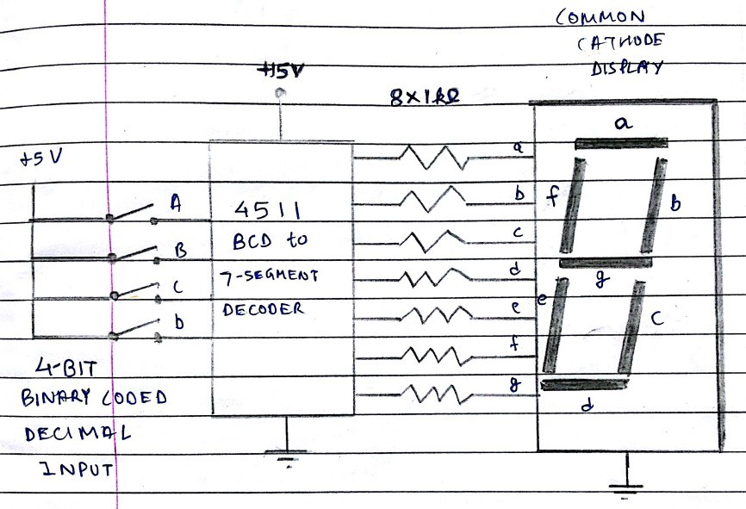

1. **Short notes on LCD**

LCD (liquid crystal display) is the technology used for displays in notebook and other smaller computers. Like light-emitting diode (LED) and gas-plasma technologies, LCDs allow displays to be much thinner than cathode ray tube (CRT) technology. LCDs consume much less power than LED and gas-display displays because they work on the principle of blocking light rather than emitting it.

An LCD is made with either a passive matrix or an active matrix display display grid. The active matrix LCD is also known as a thin film transistor (TFT) display. The passive matrix LCD has a grid of conductors with pixels located at each intersection in the grid. A current is sent across two conductors on the grid to control the light for any pixel. An active matrix has a transistor located at each pixel intersection, requiring less current to control the luminance of a pixel. For this reason, the current in an active matrix display can be switched on and off more frequently, improving the screen refresh time.

Some passive matrix LCD's have dual scanning, meaning that they scan the grid twice with current in the same time that it took for one scan in the original technology. However, active matrix is still a superior technology.

1. **Write an ALP to display the (Digits)numbers 1,2,3,etc using 7-Segment LED Display (Using Microprocessor Kit as well as Emulator)**

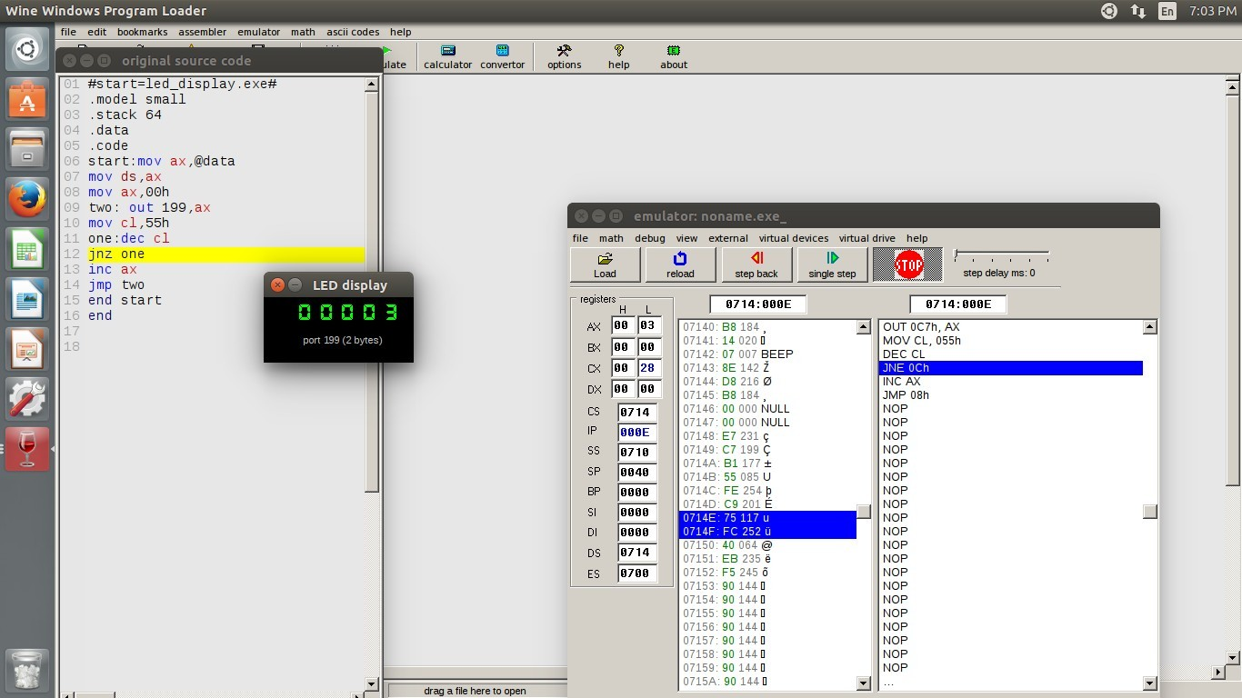

**CODE-**

#start=led_display.exe#

.model small

.stack 64

.data

.code

start:mov ax,@data mov ds,ax

mov ax,00h two: out 199,ax mov cl,55h one:dec cl

jnz one inc ax jmp two end start end